Store Spatial Sales Analytics
Completed Project and Final Report
Project Status  Completed | Data Platform  Microsoft Fabric | Reporting Tool  Power BI

1. Executive Summary
This project delivered an end-to-end spatial sales analytics solution using SQL Server, Microsoft Fabric, Direct Lake and Power BI. A normalized StoreDB database was created in SQL Server, connected securely to Microsoft Fabric through an on-premises data gateway, ingested into a Fabric Lakehouse, enriched with geographic and date dimensions, modelled through a Direct Lake semantic model, and reported through an interactive Power BI dashboard.
The completed solution supports state-level spatial analysis, KPI reporting, category analysis, time-intelligence calculations and interactive filtering by year, region, state, category, segment and ship mode. The final output demonstrates the full reporting lifecycle from local source data to cloud ingestion, semantic modelling and business intelligence visualisation.

2. Project Objectives
- Create and structure a relational sales database in SQL Server.
- Connect the local SQL Server source to Microsoft Fabric securely.
- Ingest source tables into a Fabric Lakehouse using a reusable data pipeline.
- Add geographic data for state-level spatial analysis using latitude and longitude.
- Create a Date dimension for time-intelligence reporting.
- Build a Direct Lake semantic model with correct one-to-many relationships.
- Create DAX measures for sales, profit, margin, order volume and time-based comparisons.
- Develop an interactive Power BI report containing spatial, trend, category and KPI visuals.

3. Tools and Components Used
Tool / Component | Easy Definition / Role
SQL Server | Microsoft relational database system used to store, organise and query structured data.
SQL Server Management Studio (SSMS) | Graphical application used to create the StoreDB database, tables, relationships and SQL queries.
StoreDB | The local relational database created for the project using the Superstore sales dataset.
On-Premises Data Gateway | Secure bridge that allows Microsoft Fabric to access the SQL Server running on the local computer.
Microsoft Fabric | Microsoft's unified cloud analytics platform combining data integration, engineering, storage, modelling and reporting.
Fabric Data Pipeline | Workflow used to copy data from SQL Server into Microsoft Fabric using Copy Data activities.
Fabric Lakehouse | Cloud storage and analytics layer that combines data-lake flexibility with structured analytical tables.
OneLake | Unified storage layer used by Microsoft Fabric to make data available across Fabric workloads.
StateGeography | Project geography table containing state name, state code, latitude and longitude for spatial analysis.
DateDim | Calendar dimension used for filtering dates and supporting time-intelligence calculations.
Direct Lake | Fabric semantic-model mode that allows Power BI to work directly with data stored in OneLake.
Semantic Model | Business-ready model containing tables, relationships and measures used by the Power BI report.
DAX | Data Analysis Expressions; the formula language used to create measures such as Total Sales and YoY Growth.
GeoJSON | JSON-based geographic format used to represent points, regions and boundary polygons for spatial mapping.
ArcGIS | Geographic information system platform used for mapping, spatial analysis and location intelligence.
Shape Map / Choropleth Map | Map visual that colours geographic regions according to a measure such as sales or profit.
Power BI | Business intelligence platform used to create the final interactive report and visualisations.

4. Final Solution Architecture
SQL Server / StoreDB -> On-Premises Data Gateway -> Fabric Data Pipeline -> StoreLakehouse -> Direct Lake Semantic Model -> Power BI Report

5. SQL Server Data Preparation
The source sales workbook was converted into a normalized relational database named StoreDB. The design separated operational data into related tables so that customer, location, product, order and category information could be managed without unnecessary duplication.
Table | Purpose
Customers | Stores customer identifiers and customer names.
Locations | Stores region, state and city information.
Categories | Stores the major product categories.
SubCategories | Stores subcategories linked to parent categories.
Products | Stores product information linked to subcategories.
Orders | Stores order-level information including date, customer, location, segment and ship mode.
OrderItems | Stores line-level quantity, discount, sales and profit.
StateGeography | Stores state code, latitude and longitude for geographic reporting.
DateDim | Stores calendar date, year, month and quarter attributes.

6. Implementation Evidence - SQL Server and Fabric
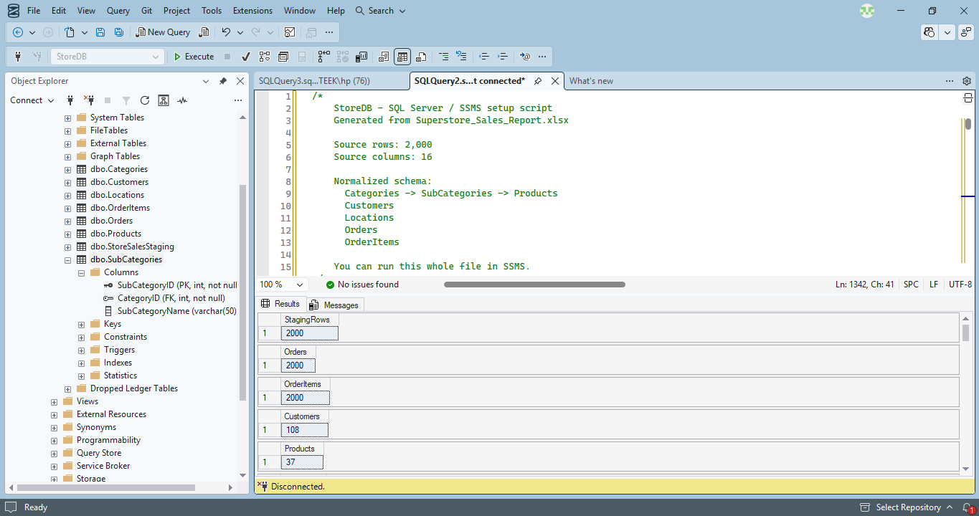
Figure 1. Normalized StoreDB tables created in SQL Server Management Studio.
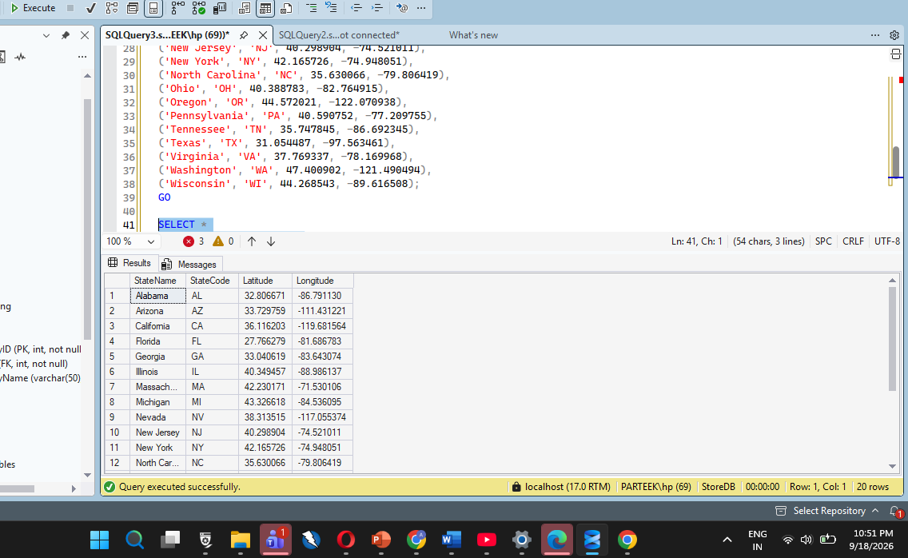
Figure 2. StateGeography data containing state codes, latitude and longitude.

7. Microsoft Fabric Ingestion
The StoreDB source was connected to Microsoft Fabric through the on-premises data gateway. A pipeline named PL_Load_StoreDB was created using Copy Data activities. Each activity copies a source table from SQL Server into StoreLakehouse. This provides a reusable ingestion process and centralises the analytical data in Fabric.
- Source: local SQL Server StoreDB.
- Connectivity: On-Premises Data Gateway.
- Pipeline: PL_Load_StoreDB.
- Destination: StoreLakehouse.
- Loaded analytical tables: Customers, Locations, Categories, SubCategories, Products, Orders, OrderItems, StateGeography and DateDim.
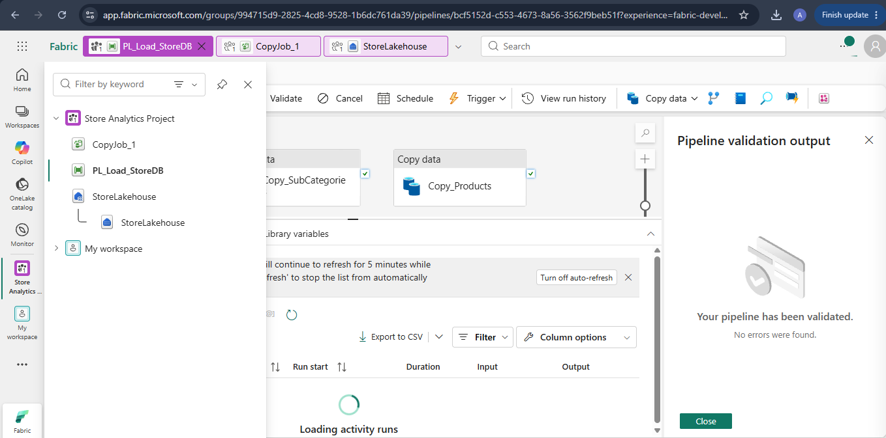
Figure 3. Fabric pipeline validation and Copy Data activities.
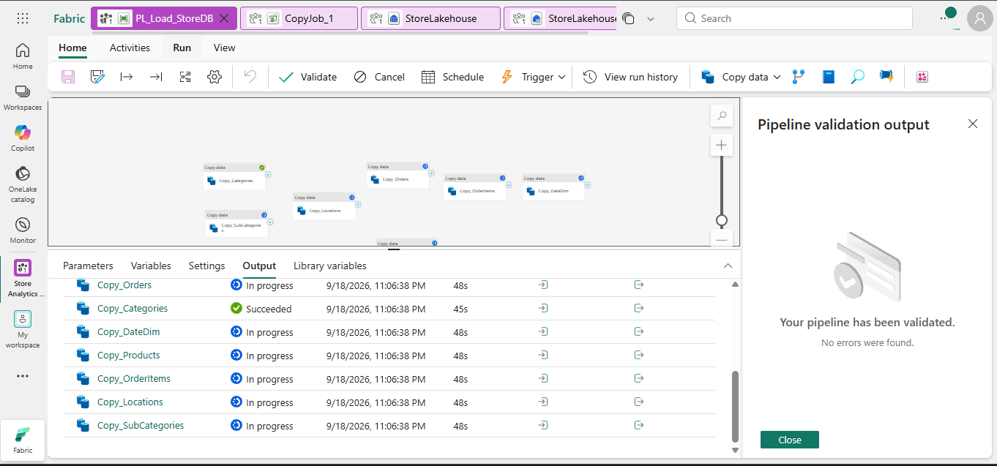
Figure 4. Expanded PL_Load_StoreDB pipeline including DateDim and StoreDB tables.

8. Spatial Data Reporting
Spatial reporting was implemented by adding the StateGeography dimension to the data model. The table provides state-level geographic attributes that can be used with Power BI map visuals. StateName links the geographic dimension to the Locations table, while latitude and longitude support coordinate-based mapping.
The solution is designed to support both coordinate mapping and boundary-based mapping. GeoJSON can be used to provide custom state boundary polygons for Shape Map visuals, while ArcGIS represents an alternative GIS platform for interactive geospatial analysis.

9. Direct Lake Semantic Model
A Direct Lake semantic model named Store_Spatial_Analytics_Model was created from the Lakehouse tables. The model uses dimension-to-fact relationships so filters propagate correctly from Date, Customer, Location, Geography, Category and Product dimensions to Orders and OrderItems.
Dimension / Parent | Relationship | Fact / Child
Customers[CustomerID] | 1 -> * | Orders[CustomerID]
Locations[LocationID] | 1 -> * | Orders[LocationID]
DateDim[DateValue] | 1 -> * | Orders[OrderDate]
Orders[OrderID] | 1 -> * | OrderItems[OrderID]
Products[ProductID] | 1 -> * | OrderItems[ProductID]
Categories[CategoryID] | 1 -> * | SubCategories[CategoryID]
SubCategories[SubCategoryID] | 1 -> * | Products[SubCategoryID]
StateGeography[StateName] | 1 -> * | Locations[StateName]
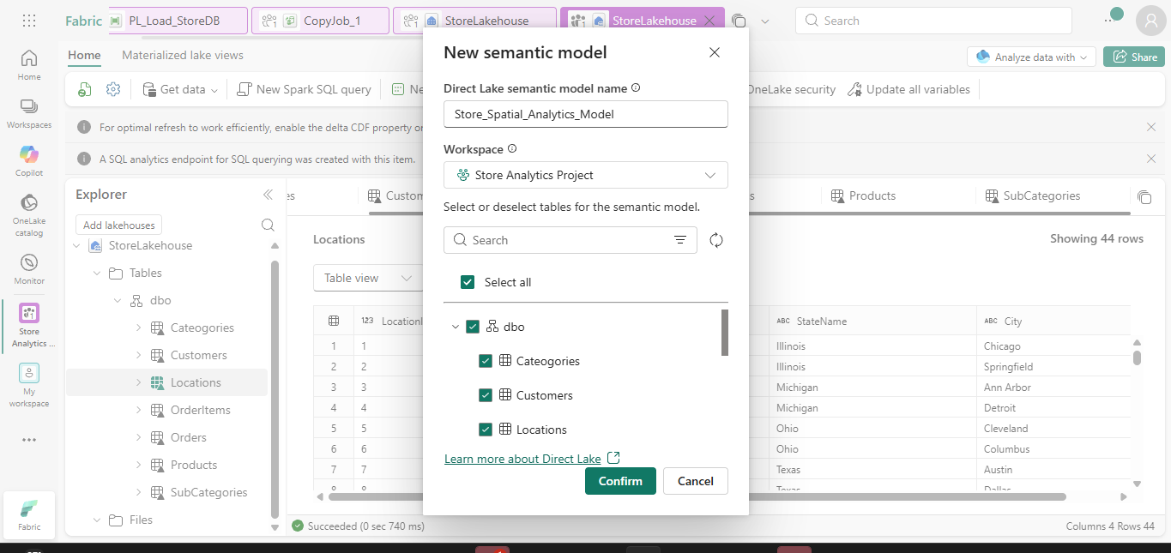
Figure 5. Creation of the Direct Lake semantic model from StoreLakehouse.
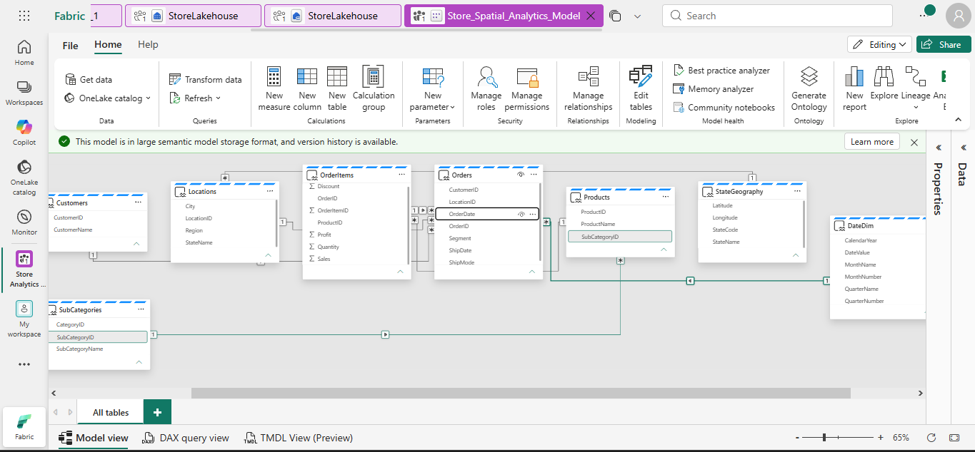
Figure 6. Final semantic model showing relationships across date, geography, product, order and customer tables.

10. DAX Measures
The semantic model contains measures required for executive KPIs, profitability analysis, order analysis and time-intelligence reporting.
Measure | Purpose
Total Sales | Total revenue generated from order items.
Total Profit | Total profit generated from sales.
Profit Margin % | Profit as a percentage of total sales.
Total Orders | Distinct count of orders.
Total Quantity | Total quantity of products sold.
Average Order Value | Average sales value per order.
Sales YTD | Year-to-date sales using DateDim.
Previous Year Sales | Sales for the comparable previous-year period.
YoY Growth % | Percentage change between current and previous-year sales.
Territory Segment | Dynamic grouping of geographic performance into High, Medium and Low.

11. Final Power BI Report
The final Power BI report, titled Store Spatial Sales Analytics, provides an interactive view of sales performance by state, category and time. The report is built directly on the Direct Lake semantic model and allows users to explore the same analytical data through multiple coordinated visuals.
- Slicers: Calendar Year, Region, State, Category, Segment and Ship Mode.
- KPI cards: Total Sales, Total Profit, Profit Margin % and Total Orders.
- Spatial visual: Total Sales by State.
- Trend visual: Total Sales over time with previous-year comparison.
- Category visual: Sales by Category.
- State performance table/matrix: state-level sales, profit, margin, orders and territory segment.
- Cross-filtering: selections in slicers and visuals update the rest of the report.
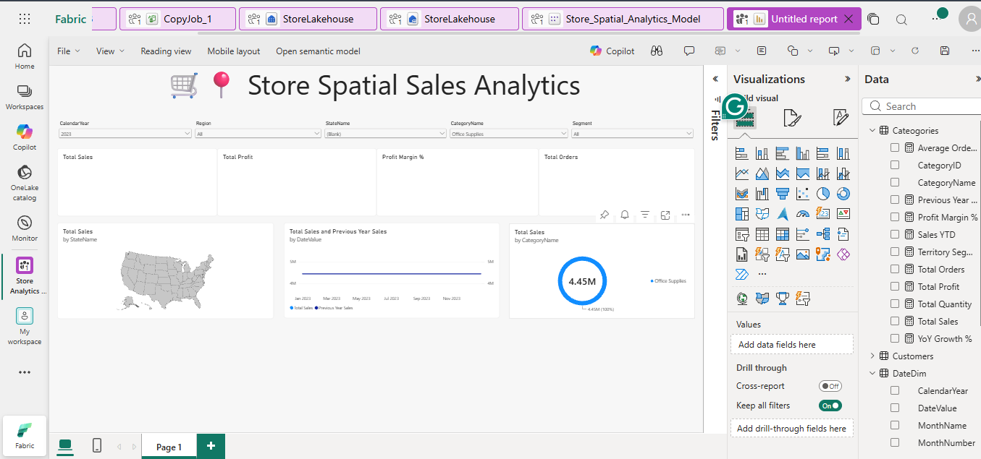
Figure 7. Final Power BI spatial sales report layout built from the Direct Lake semantic model.

12. Final Project Outcomes
Outcome | Result
End-to-end data flow | A complete path was established from local SQL Server to Microsoft Fabric and Power BI.
Reusable ingestion | The Fabric pipeline provides a repeatable process for loading source tables into the Lakehouse.
Cloud analytical storage | StoreLakehouse centralises the analytical tables inside Microsoft Fabric.
Spatial capability | StateGeography enables state-level mapping and coordinate-based geographic analysis.
Time intelligence | DateDim and DAX measures enable YTD, previous-year and YoY analysis.
Business model | The Direct Lake semantic model provides consistent relationships and reusable measures.
Interactive reporting | The final Power BI report combines KPIs, maps, trends, categories and filters in one interface.

13. Issues Identified and Resolved
Issue | Impact | Resolution
Initial Fabric activity type | A Copy Job activity required an existing Copy Job connection. | Replaced it with standard Copy Data activities for SQL Server-to-Lakehouse ingestion.
Gateway / integration runtime availability | Temporary runtime busy error occurred while loading metadata. | Retried after verifying the gateway connection and successfully loaded the source tables.
Flat sales trend | Date filters initially did not propagate correctly through the model. | Corrected relationship direction/cardinality so DateDim filters Orders and Orders filter OrderItems.
Duplicate key risk | Dimension keys must be unique on the one side of relationships. | Final model uses one-to-many relationships with unique dimension keys and full-refresh/overwrite logic where required.

14. Conclusion
The Store Spatial Sales Analytics project successfully demonstrates an end-to-end modern reporting workflow. The project combines relational database design, secure cloud ingestion, Lakehouse storage, geographic enrichment, Direct Lake semantic modelling, advanced DAX and Power BI visualisation. The completed solution provides a practical example of how Microsoft SQL Server and Microsoft Fabric can be integrated to produce scalable, interactive and location-aware business reporting.

15. Final Delivered Power BI Dashboard
The final delivered Power BI report brings together the complete reporting workflow developed in this project. It is connected to the Store_Spatial_Analytics_Model and presents the StoreDB data through interactive KPI, geographic, trend, category and state-performance visuals.
- Report title: Store Spatial Sales Analytics.
- Interactive slicers for Calendar Year, Region, State and Category.
- KPI cards for Total Sales, Total Profit, Profit Margin % and Total Orders.
- Geographic sales visual for state-level spatial analysis.
- Sales Trend visual comparing Total Sales with Previous Year Sales.
- Sales by Category visual for product-category comparison.
- State Performance table containing sales, profit, margin, orders and territory segmentation.
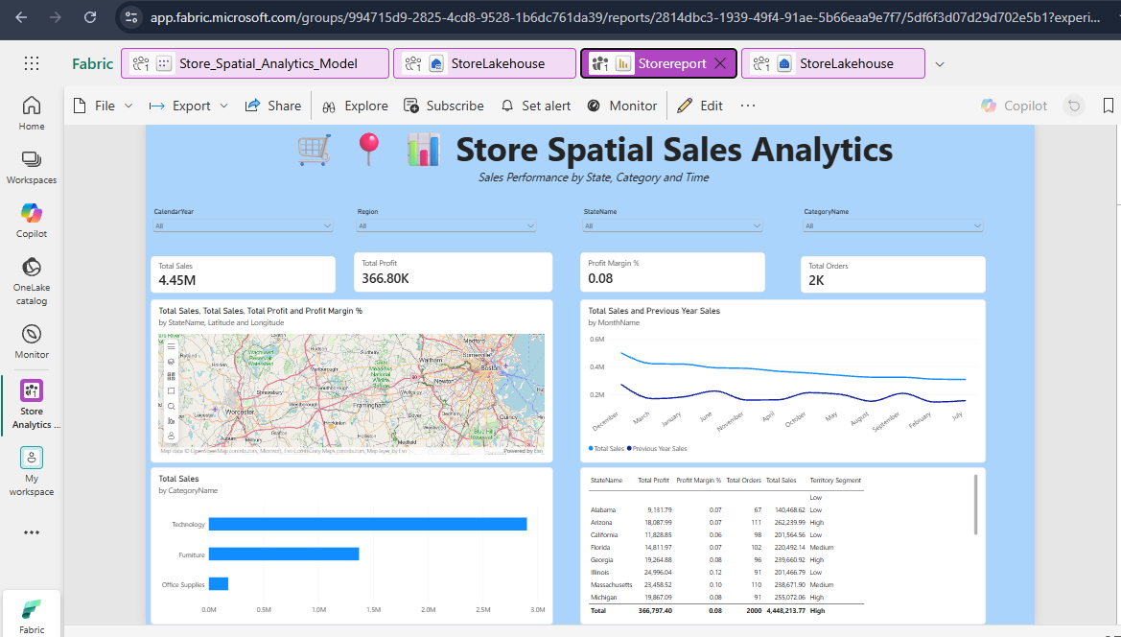
Figure 8. Final Store Spatial Sales Analytics report delivered in Microsoft Fabric / Power BI.
This final report demonstrates the completed integration of SQL Server, Microsoft Fabric Lakehouse, Direct Lake semantic modelling, DAX calculations and Power BI visualisation within one end-to-end analytics solution.

